Tugas Praktikum Search dan Sort

Nama : Ardacandra Subiantoro

NIM :18/427572/PA/18532

1. Bubble Sort :

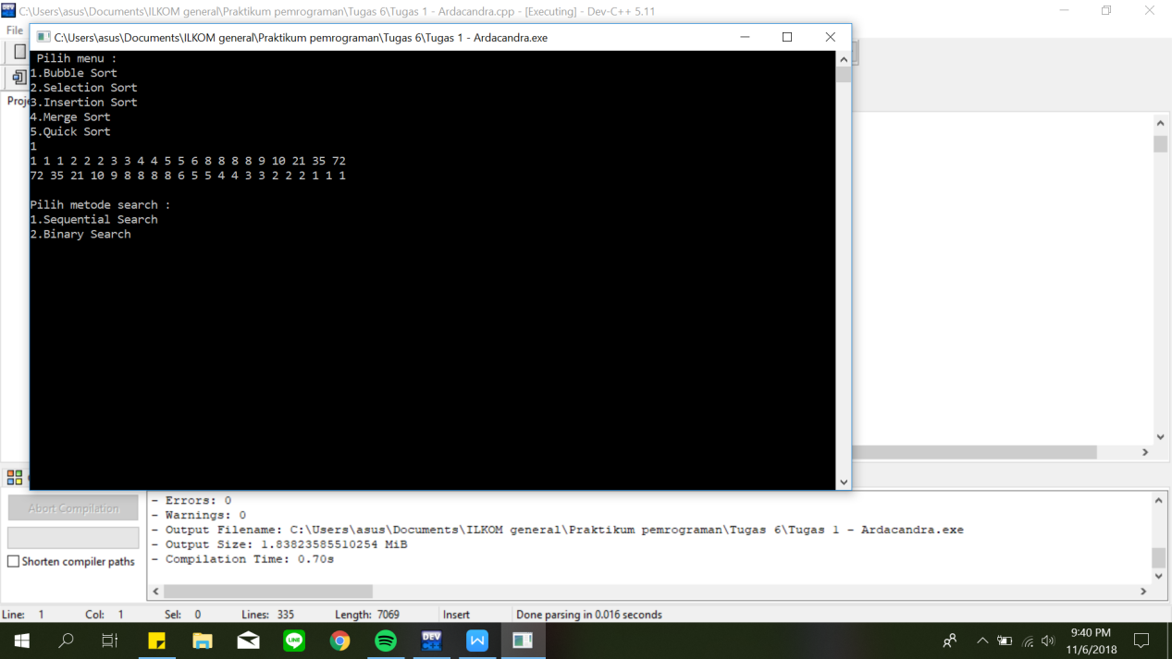

1. Selection Sort :

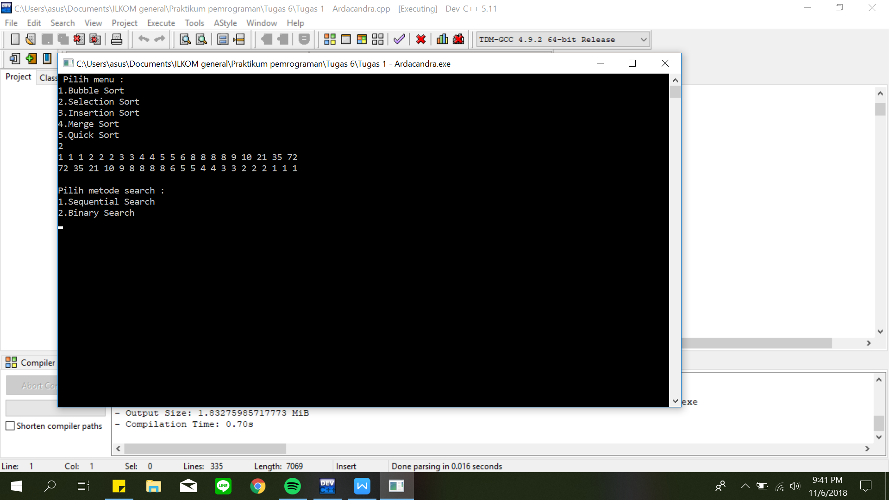

1. Insertion Sort :



1. Merge Sort :

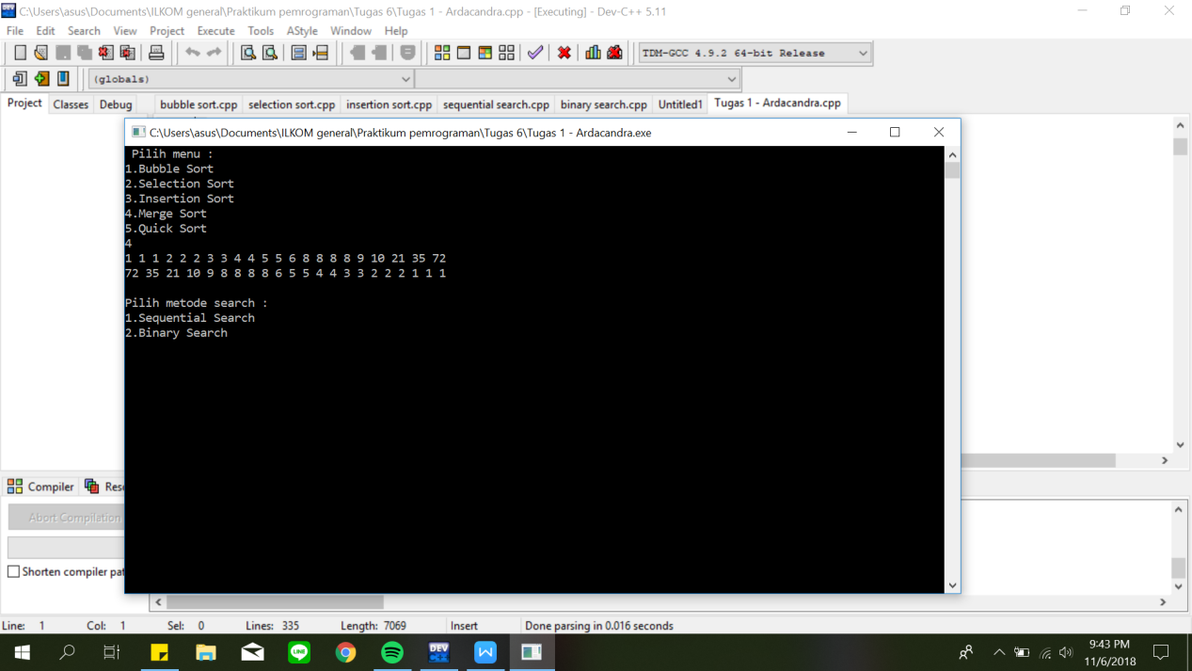

1. Quick Sort :

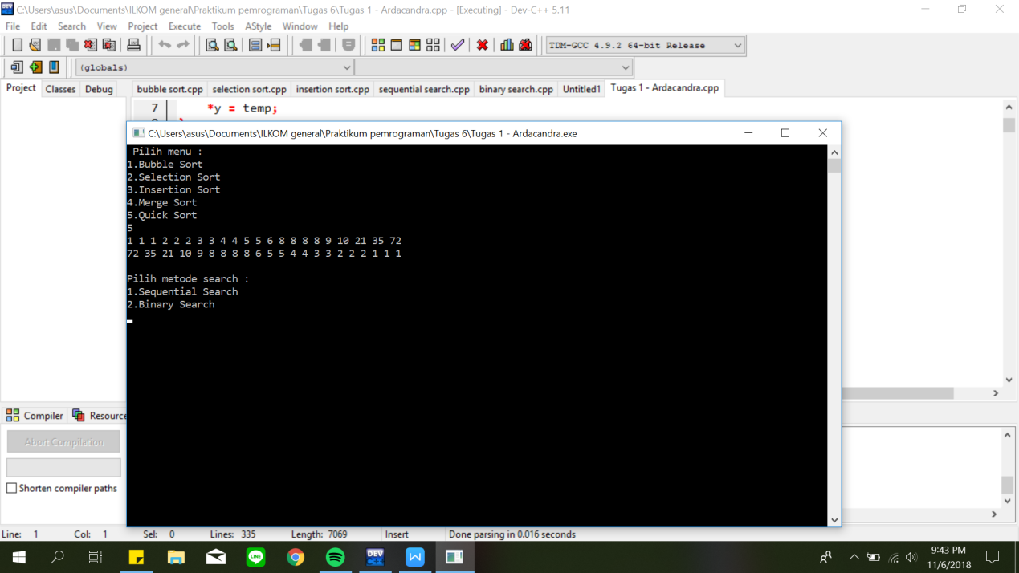

1. Sequential Search`:



1. Binary Search :

